From: http://www.strategic-culture.org/news/2016/12/19/geopolitics-globalization-and-world-order.html
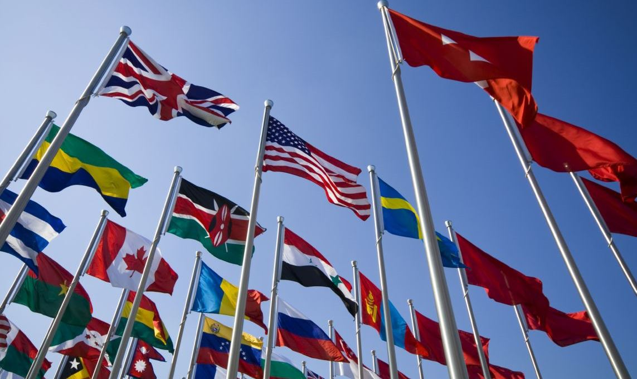
FEDERICO PIERACCINI | 19.12.2016 | OPINION

Geopolitics, Globalization and World Order
Understanding the objectives and logic that accompany the expansion of nations or empires is always of paramount importance in helping one draw lessons for the future
In this series of four articles I intend to lay a very detailed but easily understandable foundation for describing the mechanisms that drive great powers. To succeed, one must analyze the geopolitical theories that over more than a century have contributed to shaping the relationship between Washington and other world powers. Secondly, it is important to expound on how Washington’s main geopolitical opponents (China, Russia and Iran) have over the years been arranging a way to put a stop to the intrusive and overbearing actions of Washington. Finally, it is important to take note of the possibly significant changes in American foreign policy doctrine that have been occurring over the last twenty years, especially how the new Trump administration intends to change course by redefining priorities and objectives.
The first analysis will therefore focus on the international order, globalization, geopolitical theories, their translations into modern concepts, and what controlling a country’s sovereignty means.
Before examining geopolitical theories, it is important to understand the effects of globalization and the changing international order it [globalization] entails, a direct consequence of US strategy that seeks to control every aspect of the economic, political and cultural decisions made by foreign countries, usually applying military means to achieve this objective.
Globalization and the International Order
It is important to first define the international order among nations before and after the collapse of the Berlin wall, especially focusing on the consequences of existing in a globalized world.
For the first half of the twentieth century the world found itself fighting two world wars, then, during the Cold War, lasting from 1945 to 1989, the balance of power maintained by the US and USSR held the prospect of a third world war at bay. With the dissolution of the USSR, the United States, the only remaining world superpower, thought it could aspire to absolute domination over the globe, as was famously expressed through the Project for A New American Century. Putting aside for a moment perpetual wars, one of the key strategies towards fulfilling this objective was the so-called experiment of globalization, applied especially in trade, economics and finance, all of course driven by American interests.
Having achieved victory in the Cold War over its socialist rival, the world went from a capitalist system to a turbo-charged capitalist system. US corporations, thanks to this model of world globalized economy, have experienced untold riches, such as Apple and other IT corporations generating amounts of cash flow equivalent to that of small countries.
Banks and US financial institutions such as Wall Street incrementally increased their already considerable influence over foreign nations thanks to the rise of computer technology, automation and accounting deceptions such as derivatives, just to give one example. The FED implemented policies that took advantage of the role of the dollar in the globalized economy (the dollar is the premier world reserve currency). Over the years this has caused economic crises of all kinds all over the world, defrauding the entire economic system, consisting of schemes such as being able to print money at will, allowing for the financing massive wars, even going so far as lowering interest rates to 0% to keep banks and big corporations from failing – all a repudiation of the most basic rules of capitalism. All this was made possible because the US being the sole world power after 1989, allowing Washington to write the rules of the game in its favor.
Since the fall of the Berlin Wall, Wall Street, Big Oil and military corporations, health-care providers, the insurance and agricultural industries slowly replaced national governments, managing to dictate agendas and priorities. A political form of globalization has led to an expropriation of national sovereignty in Europe, with the creation of the Euro and the Lisbon Treaty signed by all EU nations in 2007.
Globalization has forced the concept of sovereign states directed by their citizens to be replaced with an international superstructure led by the United States, driving away even more citizens from the decision-making process. The European Union, and in particular the European Commission (not elected, but appointed), is unpopular not only for the decisions it has taken but also for the perception that it is an imposter making important decisions without ever having been elected.
Basically, with the end of the USSR, the international order went from a relationship between
- states made up of citizens to
- a relationship between international superstructures (NATO, UN, IMF, WTO, World Bank, EU) and citizens, with the weight of the balance of power decisively in favor of the globalists with the economic burden resting on the people.
The international order and globalization are therefore to be interpreted according to the logic of Washington, always looking for new ways to dominate the globe, preserving its role of world superpower.
It is also for this reason that it is important to understand some geopolitical theories that underlie US strategic decisions in the pursuit of world domination. These theories are some of the most important with which Washington has, over the last 70 years, tried to pursue total domination of the planet.
MacKinder + Spykman + Mahan = World Domination
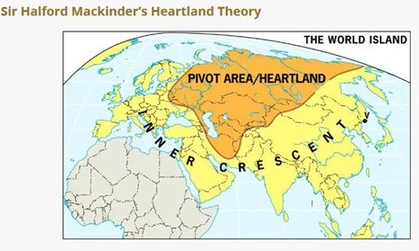
Heartland
The first geopolitical theory is the so-called Heartland theory, drawn up in 1904 by English geographer Sir Halford Mackinder. The basic principle was the following:
«Heartland or Heartlands (literally: the Heart of the Earth) is a name that was given to the central zone of the Eurasian continent, corresponding roughly to Russia and the neighboring provinces, by Sir Halford Mackinder, the English geographer and author of Democratic Ideals and Reality; the Heartlands of the theory was submitted to the Royal Geographical Society in 1904.
The Heartland was described by Mackinder as the area bounded to the west by the Volga, the Yangtze River to the east, from the Arctic to the north and south from the western Himalayas. At the time, this area was almost entirely controlled by the Russian Empire.
For Mackinder, who based his theory on the geopolitical opposition between land and sea, Heartland was the "heart" button of all the earth civilization, because logistically unapproachable by any thalassocracy. Hence the phrase that sums up the whole concept of Mackinder’s geopolitics: ‘Who controls East Europe commands the Heartland: Who controls the Heartland commands the World-Island: Who controls the World-Island commands the world’».
In terms of countries, the Heartland consists mainly of Russia, Kazakhstan, Afghanistan, Mongolia, the Central Asian countries, and parts of Iran, China, Belarus and Ukraine.
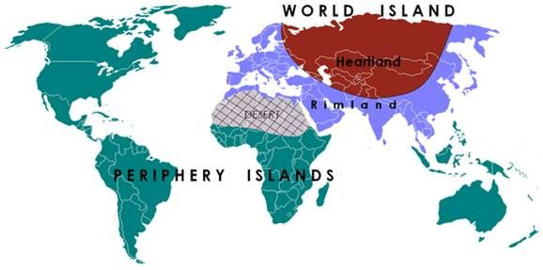
Rimland
The second geopolitical theory, another important lodestar for US foreign policy, was developed in the 1930s by the American Nicholas J. Spykman, also a student of geography as well as a scholar of MacKinder’s theory. Spykman, thanks to advancing naval technology, added to the definition of the Heartland theory the Rimland theory. The Rimland is divided into four main areas: Europe, North Africa, Middle East and Asia.
«For ‘world island’ it means the Eurasian region, ranging from Western Europe to the Far East. If for Mackinder the Tsarist empire represents the aforesaid area-pin, Spykman instead focuses on the area around Heartland, i.e. Rimland, recognizing it as a strategic point of great importance. The Rimland is characterized by the presence of rich countries, technologically advanced, with great availability of resources and easy access to the seas. Its size at the same time makes sea and land attacked by both sides. On the other hand this means that its dual nature as a possible mediating zone between the two world powers: the United States and Russia. The greatest threat from the geopolitical point of view lies in the union between Heartland and Rimland under one power».
The Rimland essentially consists of Europe (including eastern Europe), Turkey, the Middle East, the Gulf States, India, Pakistan, Southeast Asia (Brunei, Cambodia, Laos, Malaysia, Myanmar, the Philippines*, Thailand, Vietnam) and Japan.
As one can see from observing a map, the United States is not physically close to either the Rimland or the Heartland. They are both on the other side of two 6,000-mile oceans. The US is undeniably protected in this way, almost impervious to attack, with an abundance of resources and powerful allies in Europe. These are all characteristics that have favored the rise of the American superpower throughout the twentieth century.
But world domination is a different matter and, given the geographical location of the US compared to the Heartland and Rimland, first requires a large capacity to project power. Of course with two oceans in between, it is naval power through which power has been conveyed, especially in the early part of the last century.
Mahan and Maritime Power
The third geopolitical theory is based on the importance given to maritime (or naval) power. The author of this theory, propounded towards the end of 1800, was US Admiral Alfred Thayer Mahan.
«Mahan was a ‘precursor’ to international organizations. He assumed that through a union between the United States and Britain, being two maritime powers, they could unite to share the conquest of the seas. The key concept is that ‘the maritime powers are united in opposition to those continental.’ Mahan explains the concept of naval doctrine, which is the policy that states pursue in the maritime and military arenas. In order for a state to have a naval doctrine, it must possess a substantial navy, as well as of course access to the sea, adequate projection capability, adequate means, and have strategic objectives to be protected (such as security zones exposed to risk)».
As one can easily understand, these three doctrines are central to controlling the whole world. Dominating the Heartland is possible thanks to the control of the Rimland, and in order to conquer the Rimland it is necessary to control shipping routes and dominate the seas, relying upon the Mahan theory of maritime supremacy.
In this sense, seas and oceans of great geographic importance are those that encircle the Rimland: The East and South China Seas, the Philippine Sea, the Gulf of Thailand, the Celebes Sea, the Java Sea, the Andaman Sea, the Indian Ocean, the Arabian Sea, the Gulf of Aden, the Red Sea, and finally the Mediterranean.
In particular, straits such as Malacca, between Indonesia and Malaysia, or the Suez Canal, are of strategic importance due to their role as a transit route and connection between all the seas adjacent to the so-called Rimland.
A bit of history. Route to global domination
It was Hitler's Germany during World War II that tried to put into practice the theory of geopolitics MacKinder was describing, managing to seize the Heartland but ultimately amounting to nothing with the final victory of the Red Army, who rebuffed and destroyed the Nazis.
After the end of World War II, the United States placed the Soviet Union in its crosshairs, with the intention of conquering the Heartland and thereby dominating the world. Alternatively, Plan B was to prevent other nations from teaming together to dominate the Heartland. This explains the historical conflicts between the US and Iran and between Russia and China, the three most important nations composing the Heartland.
Russia, since Tsarist times and throughout the Soviet period to today, has always been in the crosshairs of the United States, given its geographical location central to the Heartland.
Iran also constitutes a valuable piece of the 'Heart of the World', which was gifted to the Anglo-Americans courtesy the Pahlavi monarchy lending itself to the American plan to conquer the heart of the land. It was only after the 1979 revolution, which ousted the Pahlavi monarchy and installed an Islamic Republic, that Tehran became an enemy of Washington.
The reason why
- Afghanistan was invaded and
- Ukraine destabilized, and why
- the Belarusian leadership is hated almost as much as is the Russian one,
is the same, namely, the geographical positions of these countries in composing the Heartland compels the US to conquer them as part of its grand strategy to dominate the world through the control of the Heartland.
The Republic of China, another constituent part of the Heartland theory, was during the Cold War the great Asian pivot thanks to Kissinger’s policy aimed at curbing the USSR and preventing the birth of a possible alliance between Tehran, Moscow and Beijing that would dominate the Heartland, especially in the late 1980s. The United States, instead of directly attacking China, used it against the Soviet Union. Washington's primary goal, as well as to expand its influence everywhere, was to prevent any kind of alliance that would control the Heartland, specially preventing any alliance or understanding between Moscow and Beijing; but this will be very well explained in my third analysis on how Eurasia reunited to reject the American global empire.
Control of a nation
Historically, control of a nation takes place through military power that allows for a variety of impositions. Also, culture is part of the process of conquering a nation. Today, other than militarily, it is mainly economic power that determines the national sovereignty of a nation. In the modern world, especially in the last three decades, if you control the economy of a nation, you control the rulers of that nation. The dollar and neoliberal experiments like globalization are basically the two most powerful and invasive American tools to employ against geopolitical opponents. The application of military force is no longer the sole means of conquering and occupying a country. Obligating the use of a foreign currency for trade or limiting military supplies from a single source, and impeding strategic decisions in the energy sector, are ways the globalist elites are able to dominate a foreign country, taking control over its policies. The European Union and the NATO-member countries are good examples of what artificially independent nations look like, because they are in reality fully dispossessed of strategic choices in the areas mentioned. Washington decides and the vassals obey.
It is not always possible to employ military power as in the Middle East, or to stage a color revolution as in Ukraine. Big and significant nations like Russia, India, China and Iran are virtually impossible to control militarily, leaving only the financial option available. In this sense, the role of central banks and the de-dollarization process are a core strategic interest for these countries as a way of maintaining their full sovereignty. In going in this direction, they deliver a dramatic blow to US aspirations for a global empire.
The next article will focus on how the United States has tried to implement these strategies, and how these strategies have changed over the last seventy years, especially over the last two decades.
Tags: European Union IMF NATO World Bank Russia US

